Movement

To make your robot reverse and turn when it hits a wall.

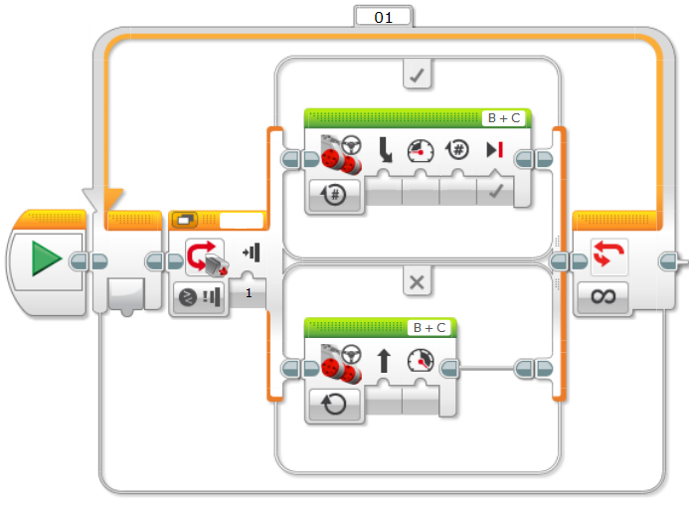

Move forward here

Reverse and turn here.

Select your sensor